6.P.2.3 | Compare the physical properties of pure substances that are independent of the amount of matter present including density, melting point, boiling point and solubility to properties that are dependent on the amount of matter present to include mass, volume and weight.
What is a pure substance? p.54 | A substance that has definite physical and chemical properties | 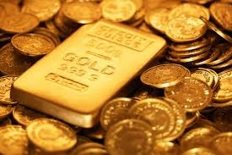
What is a solution? p. 268 | a mixture in which two or more substances are so completely blended and evenly distributed that you cannot identify the different parts | 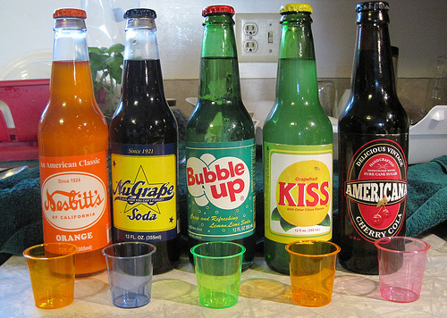
What are examples of solutions? | - Water with koolaid mix  - lemonade  - soda  - steel  - bronze (made of copper and tin)
What does soluble mean? | Capable of being dissolved  *Temperature affects solubility. | 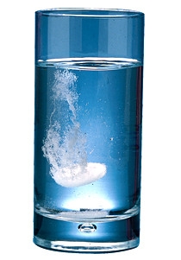
What is a solute?  p. 269 | A substance that is being dissolved in a liquid  Ex. salt water (salt is the solute) | 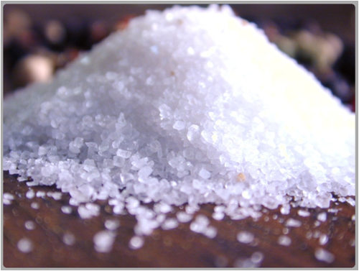
What is a solvent? | The substance in the solution that does the dissolving  *Most common solvent is water.
What is the saturation point? | The point at which a substance can receive no more of another substance in a solution under given conditions. | 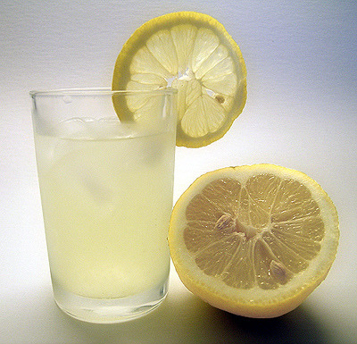
What is mass? P.7 | Describes the amount of matter in an object
What instrument can be used to find mass? | Scale/balance  One basic unit is grams (g) | 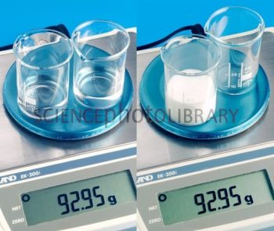
What is volume? P.9 | The amount of space that an object takes up | 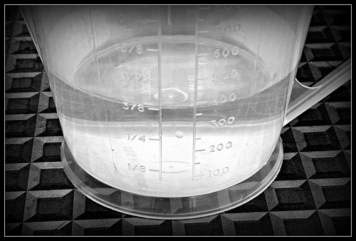
What is density? p. 13 | A measure of the amount of mass in a given volume | 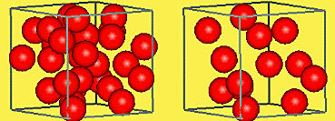
What is a physical property? p.22 | A characteristic of a pure substance that can be observed and measured without changing the identity of the substance | 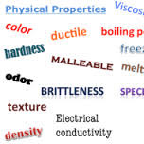
What are examples of physical properties that are not dependent upon the amount of mass present? | -density - boiling point  - solubility - melting point
What are other examples of physical properties? | *electrical conductivity  * thermal conductivity  *malleability  *luster  *magnetic attraction
What are examples of physical properties that are dependent upon the amount of mass present? | *mass  *volume  *weight

