Waves 4-1
6.P.1.1 | Compare the properties of waves to the wavelike property of energy in earthquakes, light and sound.
What is a wave? | A wave is a disturbance that transfers energy from one place to another.
What is a medium? | Any substance that a wave moves through.
Name different examples of waves and their mediums. | - Water waves-- water  - Rope waves-- rope  - Earthquake waves—Earth
What is a transverse wave? | Wave in which particles of the medium vibrate at right angles to the direction that the wave travels
Show a transverse wave and give example. | 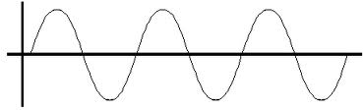  - Water waves  - Rope wave
What is a longitudinal wave? | A wave the travels in the same direction as the disturbance
Show a longitudinal wave and give examples. | 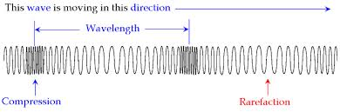  - Slinky wave  - Sound wave
What is a crest? | The highest point or peak of a wave
What is a trough? | The lowest point, or valley, of a wave
What is amplitude? | Maximum distance the particles of a medium move from their resting positions when a wave passes through.  * Tells the amount of energy in the wave  ** In sound waves, amplitude= volume
What is wavelength? | Distance between two corresponding points of adjacent waves, such as the distance between two adjacent crests of a transverse wave
Show a wave and label:  Crest, trough, wavelength, amplitude | 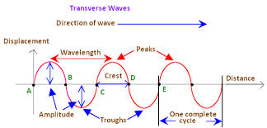
What is frequency? | The number of waves that pass a fixed point in a given amount of time  *In sound waves, frequency = pitch (how high/low a sound is)  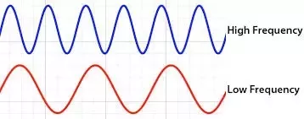
What is a compression? | A force that tends to shorten or squeeze something, decreasing its volume.
What is a rarefaction? | A decrease in density and pressure in a medium, such as air, especially when caused by the passage of a wave, such as a sound wave
Show a longitudinal wave and label:
Compression, rarefaction and wavelength.

