3-2 Matter | Explain the effect of heat on the motion of atoms through a description of what happens to particles during a change in phase.
How does heat change the motion (movement) of particles? | - Adding heat gives particles more energy = more motion  - Taking away heat gives particles less energy = less motion | 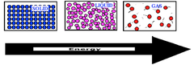
What causes states of matter to change? | Add heat/take away heat.  Add heat= particles gain energy  Lose heat= particles lose energy | 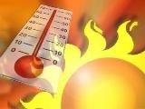
What is the melting point?  p. 78-79 | The temperature at which a solid becomes a liquid  *Particles gain energy | 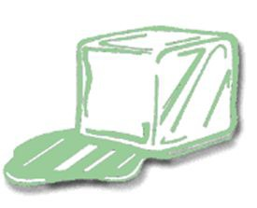
What happens at the same temperature as the melting point? | Freezing point | 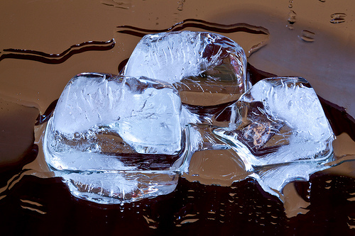
What is the freezing point? | The change in state when a liquid becomes a solid.  *Particles lose energy.
What is the melting point/freezing point of water? | 32 degrees Fahrenheit or 0 degrees Celsius | 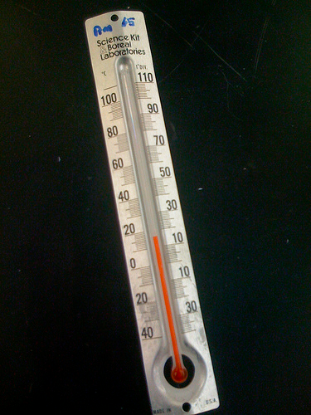
What is the boiling point?  p. 80 | The temperature at which a liquid changes or a vapor or gas  (evaporation)  *Particles gain energy | 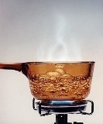
What is the boiling point of water? | 212 degrees Fahrenheit or 100 degrees Celsius | 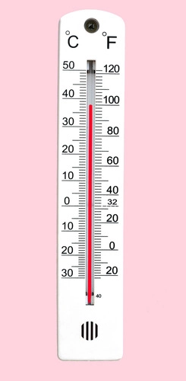
What is evaporation? | The change of state from a liquid to a gas that usually occurs at the surface of the liquid  *Particles gain energy | 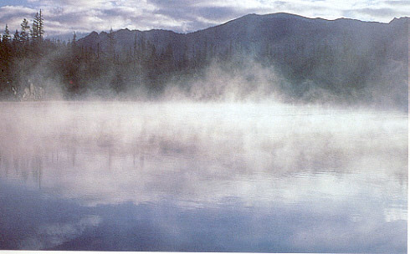
What is condensation? | The change of state from a gas to a liquid.  *Particles lose energy | 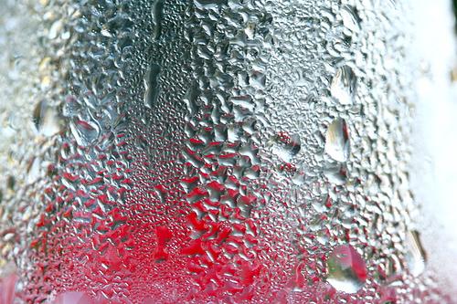
Do particles gain or lose mass when they change phases? | Neither, the mass stays the same. Mass is conserved.

