Matter 3-1 TIPS
6.P.2.1 | Recognize that all matter is made up of atoms of the same element and atoms of the same element are all alike, but are different from the atoms of other elements.
What is matter?  p. 6 | Anything that has mass and takes up space | 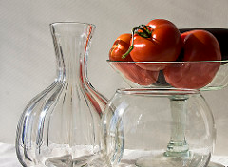
What is mass? | Describes the amount of matter in an object | 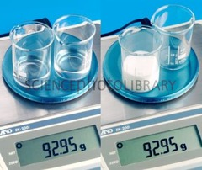
What is volume? | The amount of space that an object takes up | 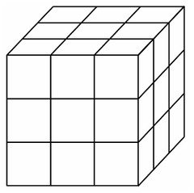
What is density? | A measure of the amount of mass in a given volume | 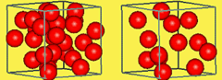
What are examples/non-examples of matter? | Examples – apples. air, water  Non-examples- sound, light, happiness | 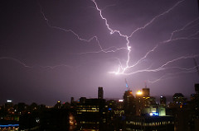
What makes up matter? | Atoms | 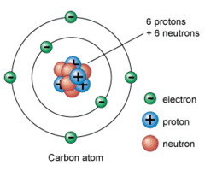
What is an atom?  p. 52 | The smallest unit of the element that maintains the properties of that element
What is an element? P.52 | Made of one or more of the same kind of atom | 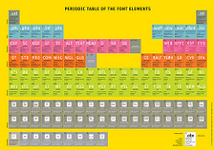
Give examples of elements?  (Periodic Table of Elements on page 172-3) | Iron- made of only iron atoms  Gold- made of only gold atoms  Oxygen- made of only oxygen atoms | 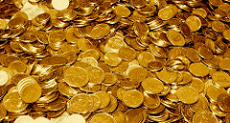
What are the three states of matter? | - Solid  - Liquid  - Gas
What are examples of solids? | Ice, table, book | 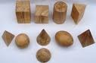
What are examples of liquids? | water, milk, orange juice | 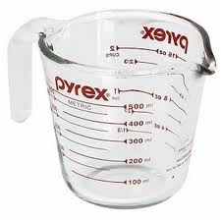
What are examples of gases | - water vapor, oxygen, air | 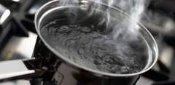
Describe/draw the solid phase.  p. 66 | - Particles packed together closely  - Definite shape/volume  - Rigid  - Particles vibrate slightly | 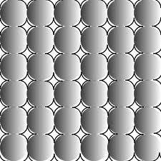
Describe/draw the liquid phase.  p. 67 | - Take the shape of a container.  - Particles can move around  - Particles touch. | 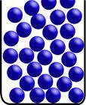
Describe/draw the gas phase.  p. 67 | - Has no definite volume or shape  - Will spread out indefinitely  - Has the most energy | 